UTILIZATION OF WASTE PLASTIC BAGS, SAND AND SAWDUST FOR PRODUCTION OF ECO-FRIENDLY BUILDING BLOCKS
¹Nyong Imoh Edem, ²Lincoln E. Njor
1 & 2 Department of Civil Engineering Technology, Federal Polytechnic Ukana, Akwa Ibom State.
Correspondent: nyongimoh@gmail.com, 08037100227
ABSTRACT
The increasing accumulation of solid waste materials such as plastic bags and sawdust poses significant environmental challenges due to their non-biodegradable nature and improper disposal. This study focuses on the assessment and utilization of waste plastic bags, sand, and sawdust in the production of sustainable building blocks as an alternative to conventional construction materials. The research explores the feasibility of incorporating these waste materials as partial or full substitutes for traditional aggregates and binders in block manufacturing. Waste plastic bags, primarily composed of polyethylene, were processed and used as a binding agent, while sand served as the primary fine aggregate and sawdust was introduced as a lightweight filler material. Different mix proportions were prepared and evaluated to determine their physical and mechanical properties, including compressive strength, density, water absorption, and thermal performance. The results reveal that the incorporation of waste plastic significantly enhances the durability and reduces water absorption of the blocks, while sawdust contributes to lower density and improved, the compressive strength has (2.2N/mm to 16.38N/mm) and density of (68g/cm to 1.58g/cm).
However, the following plastic-sawdust composite block of 13:1, plastic-sand composite block of 1:1 and plastic-sand-sawdust block of 10:3:1 were selected as the PCB with optimal characteristics. Excessive sawdust content may reduce compressive strength due to increased porosity, and plastic content can improve strength and resistance to moisture penetration, making the blocks suitable for low eco-friendly housing applications.
The implementation of this research demonstrates that the combination of waste plastic bags, sand, and sawdust is a viable approach to producing lightweight and environmentally sustainable building blocks. This innovation supports waste management strategies, reduces dependence on conventional raw materials, and contributes to the development of a circular economy in the construction industry.

1.0 Introduction
Plastics play an important role in modern society and are used daily in diverse industrial, food, agricultural, medical and pharmaceutical applications. The application of plastic materials and their composites are growing rapidly due to their low cost, ease of manufacturing and attractive qualities (Jassim 2017). Plastic is lightweight, water resistant, water retainer, expandable, strong, durable and cheap. These qualities contributed to over consumption of plastic-based products. Plastic waste makes about 13% of the total solid waste. About 300 million tons of plastic are produced globally each year of which only about 25% is recycled and the rest is landfilled (Kamaruddin et.,al 2017). Plastics frequently find their way into rivers, oceans and land. (Rochman et.al,2013). An estimated 7 million tons ends up as trash in the sea each year which cause significant environmental and health problems for fish and sea animals. Consequently, plastic waste brings serious environmental challenge to modern society because it is made of several toxic chemicals that can pollute soil, water and air if not managed properly (Rochman et.,al 2013). Plastics are made from non-biodegradable-harmful materials and land filling them would increase the volume of the waste and pollute ground water and may hider its movement (Jassim 2017). The menace of these non-biodegradable plastic bags causes severe problems to the many river and the seas and thus, it negatively affects environmental tourism and diving. In addition, many animals die after swallowing these plastic bags after their disposal. Plastic bags are also often incinerated in Nigeria, releasing toxic fumes into the air and having a negative effect on climate change. However, the waste plastics bags are generally a threat to the global environment and the production of plastics in its varied forms cannot be halted, recycling may be a solution to the threat waste plastics pose to the environment. Recycling of waste plastic is sustainable and can conserve natural resources. However, recovery and recycling of plastics remain insufficient, and millions of tons end up in landfills and oceans every year (Binici et al,2013). Plastics are man-made product of chemistry. They are made of units of reoccurring carbon atoms forming long chains of molecules (Kamaruddin et.,al 2017). The carbon atoms usually have sulfur, nitrogen, oxygen and hydrogen fillings. Plastics do not easily disintegrate due to their in-built molecular stability. They are durable because of the chemical bonds holding the molecules together. When soft, they take the shape of the mold and later set into moderately elastic or rigid form. Some materials made of plastic includes freezer bags; dispensing containers; water bottles; plates, cups and spoons; trays, soft drinks and juice containers. Although plastic is valuable, its one time use and disposal is creating a great menace to the environment. It is estimated that for every one minute, one million plastic drinking bottles are purchased. It is also further stated that barely 9% of these waste plastics are recycled and 12% burnt. 79% are gathered in dumps, natural environment and landfills. This collection is known as plastic pollution. Plastic pollution is the gathering of plastic at a location, such that it starts to adversely affect the surroundings and cause challenges for mankind, animals and plants (Lucolano et.,al 2013) It is the collection of plastic particles and objects on the globe’s environment that unduly affect humans, wild life habitat and wild life (Choi et., al 2009) plastic waste generates a lot of problems in today’s world. Toxic chemicals move from the waste into the ground via seepage. The motive of this study is thus to emphasize the need for more research on assessment of waste plastic bags sand, sawdust for building blocks for performance, and promote sustainable waste management in the construction industry.

3.0 MATERIALS AND METHODS
Experimental material
i. Waste plastic bags (low density polyethylene) which is the binding material.
ii. Sawdust which is an aggregate component obtained from timber market.
iii. Sharp sand which is an aggregate component.
ii Equipment
i Weighing balance for measurement of weights.
ii. Rule for measuring of the block dimension.
iii. Cast iron mould of 150mm cube for moulding of the block.
iv. Wire saw for trimming the sample surface. (knife can serve the same purpose were wire saw is unavailable).
v Crushing machine (universal testing machine) for determination of strength of block.
vi. Trowel and shovel for mixing purpose.
vii. Batching bucket
viii. Heating pan for both heating and mixing purposes.

Collection of Block Component Plastic
i. Plastic bags were collected with bags from the streets and refuse dumps and these plastic bags were washed, cleaned and dried
Sawdust
i. Sawdust was collected in bags from timber market
ii. The sawdust was properly mixed to make it homogeneous and then stored in bags till required.
Sieve analysis of sawdust
Sieve analysis to determine the grain size distribution of the sawdust was carried out with respect to BS 812. It is the operation of dividing a sample of aggregate into various fractions each consisting of particles of the different sizes. Coefficient of curvature (Cc) and uniformity (Cu) were determined using Eqn. 1 and Eqn. 2. The knowledge of the grading of aggregate helps a mix designer prescribe the size that could be compacted to a maximum density with a reasonable amount of work.
𝐶𝑜𝑒𝑓𝑓𝑖𝑐𝑖𝑒𝑛𝑡 𝑜𝑓 𝑢𝑛𝑖𝑓𝑜𝑟𝑚𝑖𝑡𝑦 (𝐶𝑢 )
= 𝐷60/ 𝐷10………………………..Eqn (1)
𝐶𝑜𝑒𝑓𝑓𝑖𝑐𝑖𝑒𝑛𝑡 𝑜𝑓 𝐶𝑢𝑟𝑣𝑎𝑡𝑢𝑟𝑒 (𝐶𝑐 ) = (𝐷60)/ (𝐷10) × (𝐷10)………Eqn (2)
where, D10, D30, D60 are the effective particle sizes with 10%, 30% and 60% of the sample by weight being finer accordingly.
Sand
- Sharp sand was collected in bags from a block making sites and was stored till required.

Procedures for the Mixing of (PCB) component
There are three types of batching methods, which is by volume, shovelful or weight. The batching method employed in this mixing procedures is by weight. That is the ratios are measured by weight instead of volume.it is the quickest and the cheapest way of proportioning concrete materials. Plastic was employed as the binding component. The mixes were made in three categories of plastic /sawdust, plastic /sand /sawdust and plastic and sand.

The Mixing of Plastic-Sand and Plastic-Sawdust
Waste plastic bags were removed from the storage bag, 2kg of the plastic was weighed and placed in a metal pan. The same weight of sand was measured and placed in a container. The pan with weighed plastic bag was placed on a fire fueled by dry wood. The weighed plastic bag was heated till it melts and was brought out of the fire. The melted plastic is then mixed thoroughly with the weighed sand as soon as possible. The above mixing ratio is 1:1. The above procedure is repeated for 2:1 except that the weight of the plastic is twice the weight of sand and so are the following mixes 3:1, 4:1, 5:1, 6:1, 7;1, 8:1, 10;1, 11:1. The same procedure is repeated with plastic and sawdust. It should be noted that the different mixes were chosen arbitrarily.
The Mixing of Plastic-Sand-Sawdust
The first mix which is 8:1:1 was obtained by weighing out 0.5kg of sawdust, the same weight of sand, the weight of plastic being eight times that of sand or sawdust which is 4kg. The weighed plastic was melted in a metallic pan heated by wood fuel. The melted plastics are blended thoroughly with the weighed sand and sawdust. The above procedure is repeated in 10:3:1, 14:3:1, 18:3:1, 10:2:1, 10:4:1, 14:4:1, 18:4:1, 18:5;1, 10:5:1 and 14:5:1. The different mixes were chosen arbitrary to.
Casting of the Mixes into PCB
A cast iron mold of 150mm cubes and its base are clamped together to avoid the leakage of the mixes. The internal surfaces of the mold are lubricated with engine oil to prevent the development of bond between the mold and mixes. Immediately after the mixing of the plastic mix, it is put in the cast iron mold; the surface is trimmed to smoothness and allowed to harden as it cools. The cubes are then removed from the mold after hardening. All the mixes are cast as mentioned above and each mix of a cube should be two in number. The blocks were marked according to the proportion of the mix for identification. The first block is for density and compressive strength determination and the second for water absorption determination. The blocks were conveyed to laboratory for test purposes.
Parameters measured include the following; Compressive strength, density and water absorption of the blocks.
Compressive Strength Determination of PCB
The first set of each block mix are crushed under constant loading factor in the universal testing machine to note the respective compressive strength. In the insertion of the block into the universal testing machine, care must be taken to make sure that the block is at the center of the crushing base. The picture of universal testing machine is shown in plate I.

PLATE I
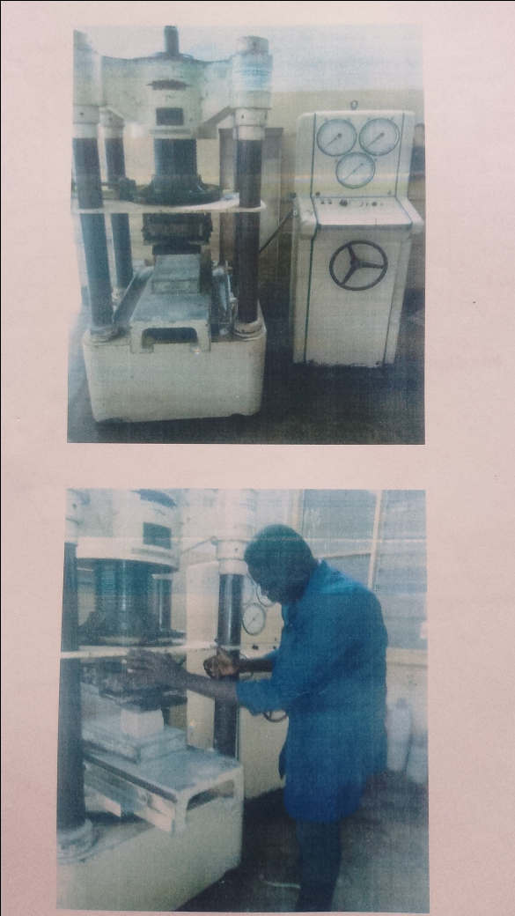

Universal testing machine
Density Determination of PCB
Just before the crushing of the cube mixes, the blocks are weighed in a weighing balance to note the weight.
Density is calculated as:
Density = weight /volume of container ……………………………………………………3.1

Water Absorption of PCB
The second set of block mix is weighed at its dry state and the weight is noted. The block is then submerged in water for 24hrs. It was removed from the water, cleaned and weighed again. According to (Rochman et.,al 2013). Water absorption is calculated as follows:
Water absorption = increase in weight /dry weight
= (W₂ –W₁)/W₁…………………………………………..3.2
Where:
W₂ = the weight of block after 24Hrs of submergence in water
W₁ =the dry weight of the block.
Precaution was taken by wearing eye goggle and nose mask against the fume from the the melting plastics.

4.0 RESULTS AND DISCUSSION

4.1 Results and Discussion of physical Parameters of PCB
In this section comments will be made on the results obtained from laboratory tests. The results of the physical parameters are shown in graphical plots with respect to the constituent content and other physical parameter to note the relationship with its behavior. It will be also noticed that most of the proposed mixes are not feasible for it cannot be mixed because of the high quantity of sawdust. The specimen of plastic, sand and sawdust composite blocks is shown in plate II
Table 4.1 to 4.2 shown all the results of the test conducted on the PCBs. The standard range for dry density of sandcrete block with load bearing is usually given as 1500 to 1900kg/m³(Ezeah.et al 2021) All the PCBs are written the standard of densities. Light weight concrete density is 0.4g/cm³ – 1.7g/cm³ Thus, PCBs of this research study are light weight blocks. Nigeria industrial standard, review 2004 limits the average water absorption of common building bricks to 12% by weight after immersion is cold water for 24 hours. Thus, the water absorption of PCBs is satisfactory with standards except 10:5:1 PCB. The minimum permissible strength of blocks for non-structural building purposes is 2.5N/mm²(Nigeria standard organization 2004). PCBs satisfy the strength recruitment of building blocks except 10:5:1, 10:1, 11:1 and 12:1 of PCBs.

PlateII
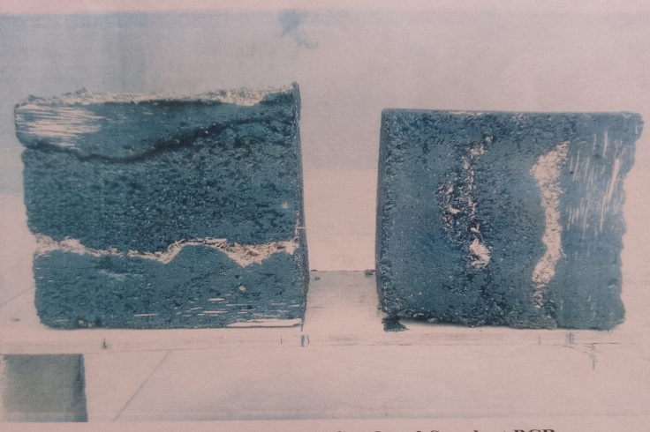

Plate II: Specimen of Plastic, sand and Sawdust Composite Blocks.

Table 4.1 Characteristics of plastic-sand-sawdust composite Block
S/No | Mix | Density  (g/cm³⁾) | Compressive str. (N/mm³) | Water absorption (%) | Sand Content (%) | Sawdust Content (%)
1 | 10;3:1 | 0.94 | 10.36 | 6.30 | 21.40 | 7.14
2 | 14:3:1 | 1:03 | 14.30 | 0.30 | 16.70 | 5.85
3 | 17:3:1 | 1;07 | 15.50 | 1.70 | 13.60 | 4.55
4 | 10:2;1 | 0.95 | 12.61 | 0.43 | 15.38 | 7.69
5 | 10:4:1 | 1:04 | 2.70 | 4.80 | 26.70 | 6.67
6 | 15;4:1 | 0.99 | 3.90 | 4.40 | 17.89 | 5.26
7 | 17:4:1 | 1;05 | 9.60 | 1.10 | 20.83 | 4.35
8 | 17:5:1 | 1:13 | 7.40 | 20.00 | 31.25 | 4.17
8 | 10:5:1 | 1:00 | 1.02 | 46.00 | 25.00 | 6.25
10 | 14:5:1 | 1:05 | 3.30 | 1.20 | 31.25 | 5.00

Table 4.2 Characteristics of Plastic – Sand Composite Blocks
S/No | Mix | Density (g/cm³⁾) | Compressive str. (N/mm³) | Water absorption (%) | Sand Content
1 | 1:1 | 1.58 | 9.33 | 0.51 | 50.00
2 | 2:1 | 1.23 | 11.52 | 0.44 | 30.00
3 | 3;1 | 1.14 | 12.07 | 0.42 | 25.00
4 | 4;1 | 1.10 | 12.58 | 0.42 | 20.00
5 | 5:1 | 1.08 | 12.89 | 0.37 | 17.00
6 | 6;1 | 1.08 | 13.68 | 0.50 | 14.00
7 | 7;1 | 1.08 | 14.33 | 0.32 | 10.00
8 | 8:1 | 1.07 | 15.23 | 0.30 | 11.00
8 | 9:1 | 1.07 | 15.85 | 0.31 | 10.00
10 | 10:1 | 1.07 | 16.38 | 0.00 | 9.00

Table 4.3 Characteristics of Plastic – Sawdust Composite Blocks
S/No | Mix | Density (g/cm³⁾) | Compressive str. (N/mm³) | Water absorption (%) | Sand Content
1 | 1:1
2 | 3:1
3 | 5;1
4 | 10;1 | 0.68 | 2:23 | 17.10 | 9.10
5 | 11;1 | 0.71 | 2:29 | 5.30 | 8.30
6 | 12:1 | 0.74 | 2:30 | 2.40 | 7.70
7 | 13;1 | 0.76 | 6:27 | 2.10 | 7.10
8 | 14;1 | 0.78 | 8:97 | 1.90 | 6.70
8 | 15:1 | 0.81 | 9:22 | 2.00 | 6.30
10 | 16:1 | 0.83 | 9:40 | 0.74 | 5.90
11 | 17:1 | 0.84 | 9:95 | 0.50 | 5.60
12 | 18;1 | 0.87 | 10:56 | 0.56 | 5.30
13 | 19;1 | 0.88 | 11:01 | 0.50 | 5.00
14 | 20:1 | 0.89 | 11:43 | 0.00 | 4.80

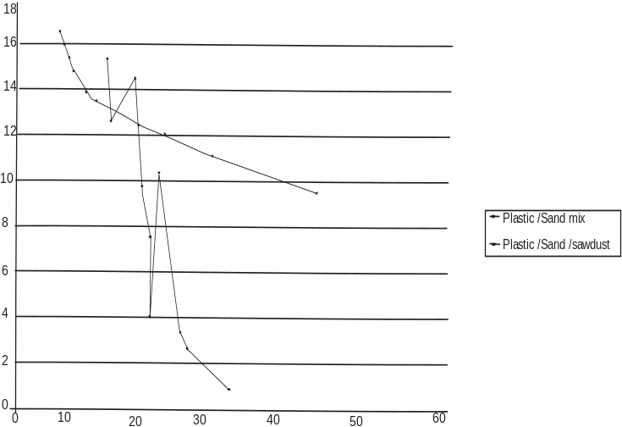
Compressive Strength (N/mm²)
FIGURE 4.1 - Relationship between compressive strength and sand content of PCB
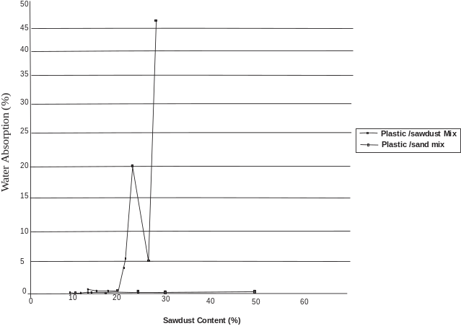
FIGURE 4.2 Relationship between water Absorption and Sand content of PBC
Compressive Strength of PCBs
In Figure 4:1. the compressive strength for the plastic –sand composite block showed decreased in value from 16.38N /mm² to 9.33N/mm² when the sand content is increased. About 45% increase in sand content resulted to about 4% decrease in the strength of the block, in the sense that increase in sand content resulted to reduction in compressive strength of the blocks. It is important to notice the high strength of plastic –sand composite block compared with strengths of plastic –sawdust and plastic-sand-sawdust composite block.
In plastic-sand-sawdust composite block, about 45% increase in sand content resulted to about 32% decrease in compressive strength of plastic-sand-sawdust composite block.
In figure 4.2, shows the relationship between water absorption and sand content. From the figure, it can be seen that increase in sand content resulted to higher absorption even though the increase is very small. The average water absorption of plastic-sand composite block is low compare with average water absorption of sandcrete blocks standard. The low water absorption of plastic / sand could be as a result of higher adhesive force between the melted plastic and sand during fusion. This force thereby reduces the void in the plastic / sand blocks. This could be the reason why the plastic – sand composite blocks have high density and compressive strength.
Since high percentage of sawdust and sand is attributable to higher water absorption. It is obvious that plastic is a low water absorption binding materials.
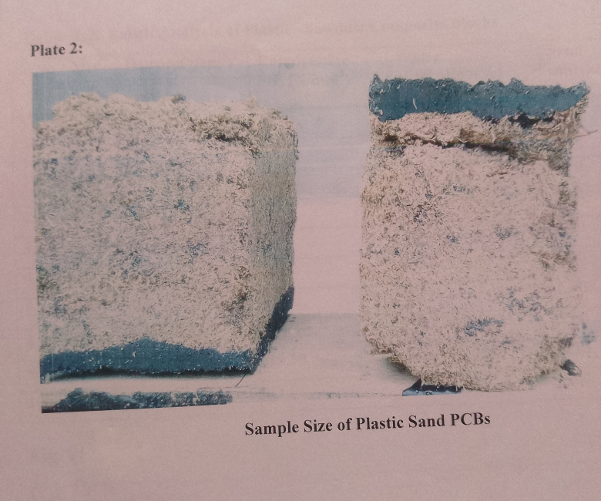
PLATE III

Plastic Sand Composite

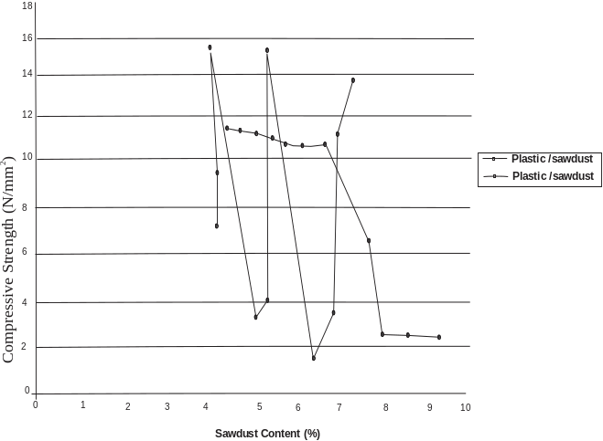
Relationship between compressive strength and sawdust content of PCBs FIGURE 4.3
In Figure 4.3, it can be seen also that the compressive strength of plastic – sawdust composite block decreases with increase in sawdust content. About 45% increase in sawdust content will result in 40% decrease in compressive strength of the plastic – sawdust composite block. The reduction in strength of the plastic –sawdust composite block. The reduction in strength is quite high compare with the reduction of strength of plastic – sand composite block. However, when the average water absorption of plastic –sawdust composite blocks are correlated with the average values of water absorption of cement /sawdust mix, it was observed that average value of water absorption of plastic –sawdust composite blocks is considerably low. In plastic –sand – sawdust composite block the water absorption rises from 3% to 46%. From Figure 4.3, the range of variation of water absorption is higher than that of plastic –sawdust composite block.

5.0 CONCLUSION AND RECOMMEDATION
CONCLUSION
This work is to eradicate waste plastic bags from the environment. Most importantly, the use of this block will lead to the removal of waste plastic from the street with the problem it poses to the environment, and will impose the aesthetics of the environment, if plastic sand composite of 7:1 mixture is considered as block for building purpose, it will be estimated that the weight of a unit block of this mix is 11.4kg,also a 1m by 1m floor area will require approximately 54.5kg of waste plastic bags of 7:1 According to(Rochman, et.al 2013).However, the plastic sand composite of 7:1,plastic sawdust composite 15:1 and plastic sawdust sand 10:3:1 are found to be appropriate mixes. They have high strength ranging from 6.27N/mm² to 10.31 compared with the recommended strength by 2.5N/mm² Nigeria Standard Organization(2004) and it can be used for internal and external.

RECOMMENDATION
The main objective of this research is to eradicate plastics waste bags from the street and dumping point. Corporate body individual and government at all level should play a role and implement of this research, this can be achieved by the following
- Individual and universities should apprise the government on the necessity and feasibility of this research study
- Government should make empowerment, especially youth to collect the waste plastic bags from dumping site, street and sell to entrepreneur for block making
- Universities should educate people on the benefit of the blocks as an advert in the media. The appropriate media is through television and posters.

References
Awoyeraa, P.O.; Adesina, A. Plastic wastes to construction products: Status, limitations and future perspective. Case Stud. Constr. Mater. 2020, 12, e00330
Agyeman, N. K. Obeng-Ahenkor, S. Assiamahd, and G. T. Twumasi, “Exploiting recycled plastic waste as an alternative binder for paving blocks production.” Case Studies in Construction Materials. 11. doi: https://doi.org/10.1016/j.cscm.2019.e00246, 2019.
Binici H, Gemci R, Kaplan H (2012) Physical and mechanical properties of mortar without cement. J Constr Build Mater 28: 357-6
Choi YW, Kim YJ, Lachemi M (2009) Characteristics of mortar and concrete containing fine aggregate manufactured from recycled plastic waste polyethylene bottles. Constr Build Mater 23: 2829-35
Jassim AK (2017) Recycling of Polyethylene waste to produce plastic cement. Procedia Manuf 8: 635-2.
Khadke, S.; Gupta, P.; Rachakunta, S.; Mahata, C.; Dawn, S.; Sharma, M.; Verma, D.; Pradhan,
Krishna, A.M.S.; Ramakrishna, S.; et al. Efficient Plastic Recycling and Remolding Circular Economy Using the Technology of Trust–Blockchain. Sustainability 2021, 13, 9142.
Kamaruddin MA, Abdullah M MA, Zawawi MH, Zainol MRRA (2017) Potential use of plastic waste as construction materials: recent progress and future prospect. IOP Conference: Mater Sci Eng: 26
Lucolano F, Liguori B, Caputo D, Colaugelo F (2013) Recycled plastic aggregate in mortar composition: Effect of physical and mechanical properties. Mater Des 52: 916-22.
M. Karthikeyan, K. Balamurali, K. Barath, P. Manoj and R. Janarthanan, “Utilization of Waste Plastic in Concrete”. International Research Journal of Engineering and Technology. 6(4), (2019), 1400- 1405
Osarumwense, J.O.; Salokun, O.; Okundaye, A.O. Utilization of low density polyethylene (LDPE) plastic wastes in the production of paving tiles. J. Mater. Environ. Sci. 2020, 11, 2052–2060
Rochman CM, Brown MA, Halpern BS, Hentschel BT, Hoh E, et al.(2013) Classify plastic as hazardous material. Nat 494: 169-171.
Silva RV, de Brito J, Dhir RK (2014) Properties and composition of recycled aggregates from construction and demolition waste suitable for concrete production. Constr Build Mater 65: 201-17
Ursua, J.R.S. Plastic wastes, glass bottles, and paper: Eco-building materials for making sand bricks. J. Nat. Allied. Sci. 2019, 3, 46–52. Available online: https://www.psurj.org/wp-content/uploads/2020/05/2019_7_JONAS_UrsuaPlasticWastes_46-52_ word.pdf (accessed on 27 February 2022).
Tapkire G, Parihar S, Patil P, Kuavat HR (2014) Recycling plastic used in concrete paver block. Int J Res Eng Technol 3: 33

